Freshdesk
File Upload Process
14 September 2018
[INTERNAL USE]

© 2018 Teamgage Pty Ltd. All rights reserved. Commercial in confidence.
+61 8 7078 5939 | mail@teamgage.com | teamgage.com

File Upload.

Steps:
- Sign In to Teamgage at https://www.teamgage.com/
- In the left hand menu, you will see a new option: “Files”
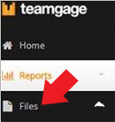
- Click on the dropdown arrow next to files and select: “New”
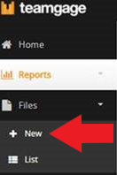
This will launch the “Upload New File” screen
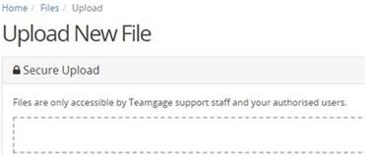
- Upload your spreadsheet ensuring that it is using the correct format.
- Teamgage will download your spreadsheet and process it. You will receive automated emails advising on the status of the spreadsheet during this process.

